

|  |  |  |  |  |  |  |
| --- | --- | --- | --- | --- | --- | --- |
|  | | | | | | |
|  | | Semester Project Report | | |  | |
|  |  | | | | |  |
|  | | |  |  | | |
|  | | | Abdurrahim Muhammad Ghani Reg no:369247 |  | | |
|  | | | Date—ME109 ENGINEERINGDRAWING—M.umair |  | | |

##### Introduction

This report explains how to make a shock absorber. A shock absorber or damper is a mechanical or [hydraulic](https://en.wikipedia.org/wiki/Hydraulics) device designed to absorb and [damp](https://en.wikipedia.org/wiki/Damping_ratio) [shock](https://en.wikipedia.org/wiki/Shock_(mechanics)) impulses. It converts one form of energy to heat energy which is dissipated.. In their simplest form, shock absorbers are hydraulic (oil) pump like devices that help to control the impact and rebound movement of your vehicle’s springs and suspension. Along with smoothening out bumps and vibrations, the key role of the shock absorber is to ensure that the vehicle’s tires remain in contact with the road surface at all times, which ensures the safest control and braking response from your car. This report will explain the geometrical shape of shock absorber. The shock absorber is like a spring with two connecting rods

##### 3D Model Development

**Description**

Pneumatic and hydraulic shock absorber take commonly take the form of cylinder with a sliding piston inside. The cylinder is filled with fluid or air. The fluid -filled piston combination is a dashpot

**Geometrical shape and reason to adopt 3d geometry**

The shock absorber shape is a mixture of spring and connecting rod but it is symmetrical. There is also two discs in it in which one is fixed and other is moveable. The 3d geometry was used because it is easier to understand the structure of shock absorber. The Multiview could be difficult to understand due to spring and inner parts. The modeling commands are used as follows:

**Steps**

* Make a circle with radius of 2,10,5 with same center
* Extrude a big circle with 2 units
* Extrude a 5 radius circle about 15 units in opposite direction
* Make a straight line about 3 units on extruded circle that is 15 units, then make a rectangle such that it lies between about 5 radius and 10 radius circle
* Join the rectangle lines with join command and mirror the rectangle with put midpoint as centre of circle
* Extrude both rectangles 5 units toward the circle in which you make a center
* Subtract the extruded rectangle from the extrude circle **Diagram, engineering drawing

  Description automatically generated**
* Change the view of the object as shown in object and set the ucs that ircle can be made

* Hide the isolated circle that was extruded 15
* Make the 7 units Perpendicular line from disc that is the midpoint of the disc
* Make a circle about 5,2 units radius at that point and erase the line
* Extrude both circle back at 5 units and hide smaller circle
* Then extrude the circle in opposite direction about 5 units
* End the object isolation and then extrude the circle in opposite direction which was extruded about 10 units
* Apply The subtract command in such away select the whole object except the extruded inner circle and then select inner circle The hole will be created
* Apply fillet top edges about 2.5 radius
* Apply line about 50 units in a way that it starts from lower part of disc
* Select the connecting portion of the rod and mirror it
* Isolate the original and connecting rod and erase the latest line
* Make a circle of Radius of 6 units at lower part of copied connecting rod and the center of circle is same as the lower potion (look like a circle)
* Extrude the latest circle of 40
* Apply helix command at the lowest part of body, take the radius of 6 and 40 distance and apply turns 10
* Make a polygon(3 sides and inscribed in circle about 1 radius) and sweep it with the spring
* Unionize the spring and cylinder,
* Make the a circle at the top of connecting rod i.e diameter 20
* Isolate everything except the circle
* Make a polygon(3 side and inscribed in circle, Radius would be 2) placed as shown in figure

* Trim the part to make the part that that is a inside the circle
* Filet the polygon part about 2.5 Radius and then polar away such and then trim

Before trimming after trimming

* Trim the circular region and extrude it about 3 units.End isolation and then isolate everting about the immovable disc
* Apply helix command( 8 radius and distance is 4,6turns) toward the other connecting portion
* Make a circle about 4 diameter and sweep it with spring,End isolation and make a circle(4 diamrter) at the disc and extrude towards other connecting rod about 50
* The Fitized disc is adjusted by using move command

**Circle command:**

The circles are widely used in design and drawings. The circle command is used to draw a circle by specifying the center point and radius.

**Trim command:**

The Trim command in AutoCAD is used to remove the objects, which meet the edges of other objects. It is used to remove extra lines or extra parts of an object.

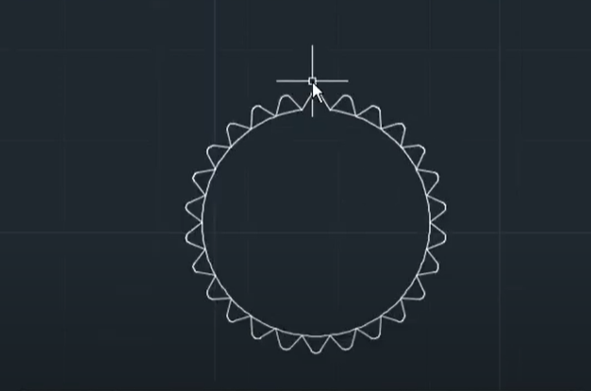

**Mirror command:**

The mirror command in AutoCAD is used to create a copy (mirror copy) of the selected object. We can also delete the source object after mirroring the object.

**Extrude command:**

The extrude command allows you to convert 2d drawing into 3d drawing. The importance of this command that it can be used to help to make 3d drawing easily.

**Fillet command:**

Rounds or fillets the edges of two 2D objects or the adjacent faces of a 3D solid.The importance of this in my project It helps the rounded the edges of connecting portion of shock absorber.

**Join command:**

Joins the endpoints of linear and curved objects to create a single object.The join command importance is that you do not have select different lines to move,copy it.You can simply click the one part to select the whole not separately select and then move or copy,e.t.c

**Helix command:**

It is used to create the 2d spiral or 3d spring.As shock absorber has a spring so I needed a helix command to create the spring

**Union command**

Combines two or more 3D solids, surfaces, or 2D regions into a single, composite 3D solid, surface, or region.. It is used to unionize the inner and spring of shock absorber

**Isolate command:**

It is used to hide the object,It helps in a way that you can work easily with other part of shock absorber easily without disturbing the position of other paets.The xommand like zoom and free orbit can be concentrated on one part.

**Subtract command:**

Creates as a new object by subtracting one overlapping region or 3D solid from another.The holes of upper and lower body is created due to this command.

Polar away command:

To use polar coordinates to specify a point, **enter a distance and an angle separated by an angle bracket (<)**. By default, angles increase in the counterclockwise direction and decrease in the clockwise direction. To specify a clockwise direction, enter a negative value for the angle.It helps in me project to apply circlular cone on every part of circle

**Sweep command:**

Creates a 3D solid or 3D surface by sweeping a 2D object or subobject along an open or closed path.

**Sectional views:**

A sectional view represents the part of an object remaining after a portion is assumed to have been cut and removed.

##### Discussion

The importance of this project is to get a know how of the command functions of AutoCAD. I chose to make a shock absorber as it is a complex part having a combination of connecting rods and spring which helps in reducing the shock when a car hits a speed bump. The shape of shock absorber is complex, but it is perfect. There could be commands in AutoCAD which could be help in the AutoCAD There is press pull which make is easy to make holes for connecting portion of rod.